

**ECEN 5053-003 Homework Assignment**

Course Name: Embedding Sensors and Actuators

Corresponding Module: C2M2

Week Number: 6

Module Name: AC Motor Control

Submitted by: Poorn Mehta

Part 1: Each question is worth 5 points.

1. You need to specify an AC induction motor for a machine which requires a minimum of 210 in-lbs of locked rotor torque from the motor. Otherwise, the machine won’t start. You find a motor on a web site that specifies 231 in-lb of locked rotor torque. According to IEC 60034-1, what is the lowest locked rotor torque (in-lbs) that your motor will supply? Will it be enough to start the motor?

Answer: **196 in-lb, No**

According to the IEC 60034-1, the tolerance in locked rotor torque is from -15% of the rated or +25% of the rated torque. For the given motor, minimum output would be 231 * 0.85 = 196 in-lb which is lesser than the required 210 in-lb. So the motor won’t start. [**[1 – page 34]**](https://new.abb.com/docs/librariesprovider53/about-downloads/low-voltage-motor-guide.pdf)

1. You purchase a motor in France designed to run at 415 Volts, 50 Hz. It has 50 kW output power, and it runs at 2978 RPM. You ship it to the United States and run it at 460 Volts, 60 Hz. What will be the new torque in N-m?

Answer: **145.9** **N-m**

As per the following table [**[2 - table 4 on page 5]**](https://docs-europe.electrocomponents.com/webdocs/001b/0900766b8001b94c.pdf),the torque will be 91% of the original torque. Also, the formula to calculate original torque is

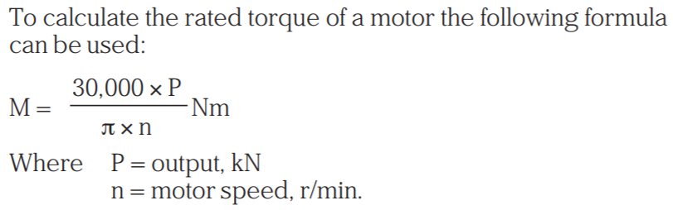

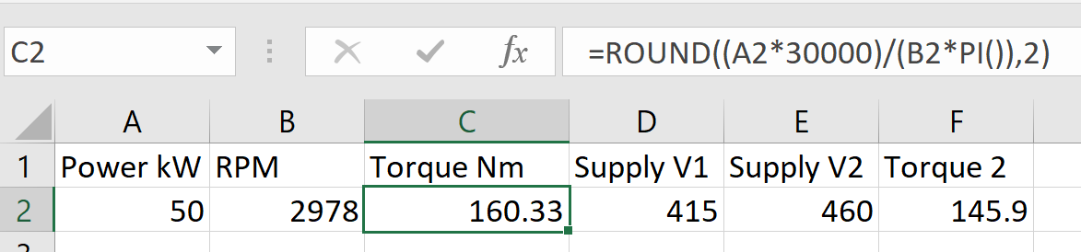

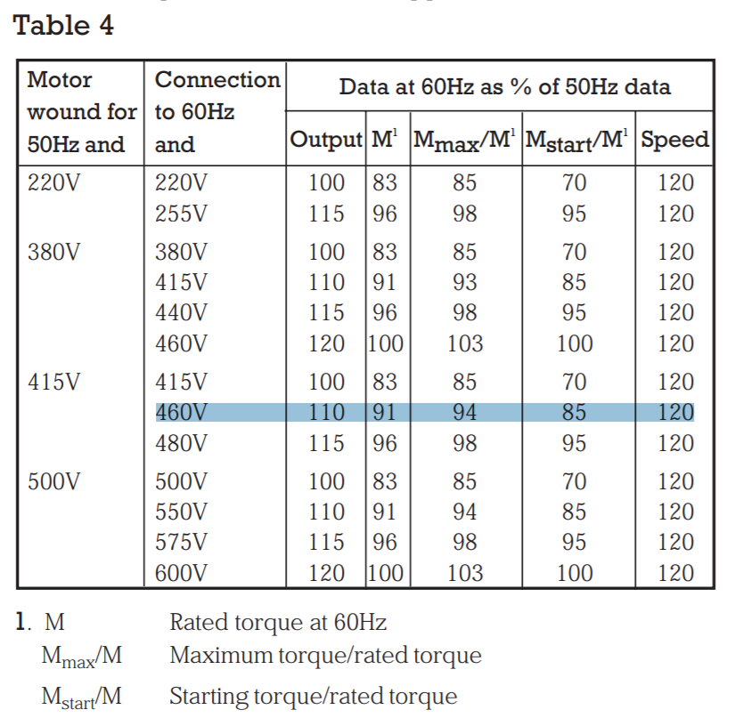

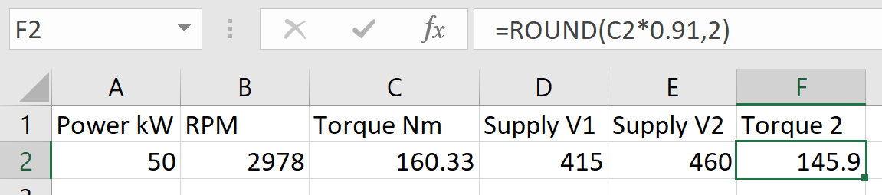

1. What is the power factor of an AC motor when the active power is 4kW and the reactive power is 3kwW? (Type a 2-decimal number)

Answer: **0.80**

According to the formula [**[3 – page 3]**](https://docs-europe.electrocomponents.com/webdocs/001b/0900766b8001b94c.pdf)**,** power factor is the cosine of the angle between active power and apparent power (which is the vector sum of active and reactive power). Since the values of them are 4kW and 3kVAr respectively, the Hypotenuse (apparent power) will be sqrt(16+9) = 5kVA. Now, as the cosine is the ration of the adjacent side to the Hypotenuse, power factor = Active Power / Apparent Power = 4 / 5 = 0.8

1. An AC motor is operating at 40°C ambient temperature conditions, and it has a temperature rating on its nameplate of Class F. What is the maximum rated internal temperature (°C) of the motor for 20,000 hours of operation? (Type an integer).

Answer: **155°C**

According to the NEMA ratings [**[4 – page 2]**](http://toshont.com/ag/mtrldesign/AG05%20%28Temperature%20Rise%29.pdf), the internal temperature would be maximum 155°C, with surface temperature being 30°C lesser than the internal.

1. NEMA (National Electrical Manufacturers’ Association) has established AC motor standards primarily associated with motors used in North America. Answer the following questions about information that NEM requires to be put on nameplates of motors.

Reference: [**[5]**](https://thegrid.rexel.com/en-us/knowledge/product-faqs/w/wiki/186/motor-nameplate-information-required-by-nema-standards)

E.1 What is the rated voltage?

Answer: **This is the voltage for which the motor is designed, and also the value at which it will have optimal performance**. Although the rated voltage is a fixed value, motors are designed to operate with a voltage tolerance of 10% above and below the rated value.

E.2 What is Full Load Amps (FLA)?

Answer: This value is also known as **rated current, and as its name implies it is the current drawn by the motor when fully loaded**. The rated current is used in the specification of auxiliary components and equipment.

.

E.3 What is the Full Load RPM?

Answer: **This is the motor speed in revolutions per minute when fully loaded.**

E.4 What is the Time Rating?

Answer: **The time rating indicates how long the motor can operate at rated load safely.**

E.5 What is the Service Factor?

Answer: **The service factor is the fraction of overload a motor can handle for short periods of time, as long as it operated at rated voltage and frequency.**

1. In an AC variable speed controller what can happen if you don’t keep the ratio of voltage to frequency constant throughout the speed range

Answer: **Magnetic flux changes drastically, even achieving saturation levels. If the magnetic flux is high, then the motor will consume more current, generating more torque.**

Synchronous speed is dependent on the line frequency. When the line frequency is decreased, the equivalent impedance of the magnetic circuit decreases and therefore, resulting in the increase in motor current and torque. Now if the voltage is not reduced then magnetic flux may reach saturation levels – resulting in either damage to the motor or undefined behavior. Thus, ratio of voltage to frequency is kept constant. (Reference: Slides by professor)

1. Why is a TENV motor enclosure not suitable for an explosive gas environment?

Answer: An environment with explosive gas is considered to be dangerous for non-specialized motors. There are two factors which are important to prevent a massive explosion in such environments: (1) To contain internal explosions to the motor, limited to the enclosure and (2) To prevent igniting the surrounding explosive gas from electrical circuitry. **In TENV, even though the enclosure has no opening, some particles are small enough to get through and since the internal parts are not specifically designed to prevent sparks and consequent blast due to explosive gas ignition**, it is not recommended to operate TENV enclosed motors in such environments. (Reference: Slides by professor)

1. Suppose you need to buy a motor for a piece of automated boring equipment located 2 kilometers below the earth’s surface in a hot dusty coal mine. It will be used 5000 hours per year. Coal dust is known to be explosive. You need an intrinsically safe motor. The equipment produces a great amount of heat, so that the motor ambient temperature is up to 135° C. According to the North American ratings, what explosion proof rating of motor should you purchase?

Answer: For the given application, proper enclosure would be of **Type 9, Class II, Division I, Group F, IEC T-Code T4**. [**[6 – page 6]**](https://www.nema.org/Products/Documents/nema-enclosure-types.pdf)

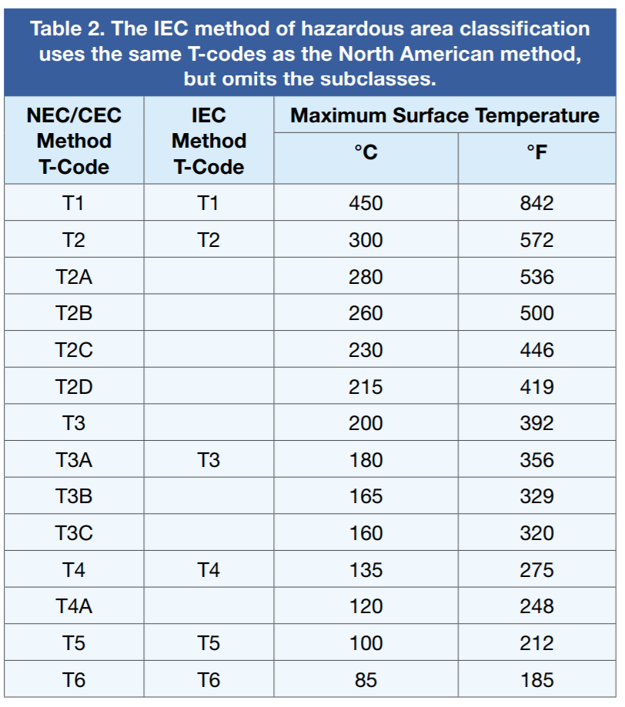

1. Suppose you are in charge of specifying an AC motor to run a pump in a pharmaceutical plant that makes antibiotic drugs. The plant is subject to FDA (Food and Drug Administration) rules that require strict cleanliness standards in manufacturing. The motor is run continuously. Temperatures in the plant are held between 18°C and 22°C. Humidity is controlled between 20% and 30%. What type of motor should you specify?

Answer: For the given application I would specify a **washdown motor with food safe specifications**, such as the ones described in here: [**[7]**](https://www.baldor.com/mvc/DownloadCenter/Files/9AKK2017-109115)

1. Suppose you are in charge of specifying an AC motor to run a pump in a factory making stainless steel. As part of normal operation, the plant uses corrosive chemicals to create the special alloys of steel. Temperatures near the pump soar to 100°C because it is located right next to a blast furnace where the internal temperatures are 1000°C. What type of motor should you specify?

Answer: For the given application, I should specify a **IEEE 841-2001 standard severe duty application motor**, such as the one described in here (**class F so can easily withstand 100°C temperature on the outside**): [**[8]**](https://www.baldor.com/catalog/CECP82276T-4#tab=%22nameplate%22)

1. What would happen to other equipment on the power line if your motor circuit did not include an AC motor contactor?

Answer: If the contactor is missing then, the AC motor will draw all of the current directly from the power line. Now the AC motors have large starting current, and they also generate very high back emf. Since the contactor (basically a high power rated relay) is missing, this current draw will affect other devices in the powerline and they’ll be powered down for sometime due to low power levels. **This may cause in instability for a while, as the devices may go through on and off states quickly. Another thing that happens is that the large back emf is directly applied to the other devices, which may have much lower supply voltage. If that is the case then those devices will get damaged due to excessive supply in pulses** [**[9]**](https://www.allaboutcircuits.com/textbook/digital/chpt-5/contactors/) .

1. These questions below are about overload relays.

L.1. How does the current to trip an overload relay or circuit breaker compare to the current that can damage a motor?

Answer: As the primary function of the overload relay is to protect the motor, the tripping current of it is kept lower than the current that can damage the motor. **Usually, it is kept 5% to 10% more than the full load ampere, and less than 1.45 times the current capacity of the conductor** [**[10]**](https://www.electricneutron.com/motor-control/overload-relay-setting-and-calculation/) .

L.2. How does the current to trip an overload relay or circuit breaker compare to the starting in the motor?

Answer: **Current to trip an overload relay is much lower than the starting current in the motor**, as the starting current is generally 6 to 9 times higher than the full load ampere, while the current to trip the overload relay is only 5% to 10% more than the full load ampere.

L.3. What is the difference between these two thermal overload relays: melting alloy and non-compensated bimetallic?

Answer: **The melting relays have to be reset manually, they use only single metal with a very specific material type which changes physical state at given temperature. The bimetallic relays are automatic resetting, using two different metals with no so stringent material selecting conditions. Also, melting relays need to be used with separately selected heaters, which is not the case for bimetallic relays** [**[11]**](https://support.industry.siemens.com/cs/document/30587303/differences-between-melting-alloy-bimetallic-and-solid-state-overload-relays?dti=0&lc=en-BY) .

The melting alloy overload relay is a lever in place, which is held in place by a solid plug of melting, or eutectic alloy. By definition, the eutectic alloy is a material which, at a given temperature, changes instantly from solid to liquid state. When enough heat is generated, this change occurs, releasing the spring-loaded mechanism and opening the contact. Once the melting alloy cools enough to return to solid state, the spring-loaded triggering mechanism must be reset by turning against a ratchet.

However, A bimetallic overload relay is a small heater element in a series with the motor and a bimetal strip that can be used as a trip lever. The bimetal strip is made of two dissimilar metals bonded together. The two metals have different thermal expansion characteristics, so the bimetal strip bends at a given rate when heated. Under normal operating conditions, the heat generated by the element is not sufficient to cause the bimetal strip. As current rises, heat thus rises. The hotter the bimetal strip becomes, the more it bends. In a condition that tripped, the motor is tripped. The bimetal strip has cooled and reshaped itself, restarting the motor. If the cause of the overload still exists, the relay will again and reset at given intervals. Care must be exercised in the selection of this type of overload relay, since repeated cycling will eventually damage the motor.

L.4. What is the fundamental difference between a motor logic solid state overload relay and a thermal overload relay?

Answer: The fundamental difference between the two is that the **Thermal overload relays are designed to mimic the heat generated in the motor**. They simulate the motor heating by passing motor current through their mechanism, and dependent on the temperature generated through this current consumption, the relay is tripped. On the other hand, in **solid-state overload relays, the motor current is measured by current transformers and then converted into an electronic signal**. This results in much less current consumption while the Solid State relay is operating, and provides better results in many conditions [**[12]**](http://ecatalog.weg.net/files/wegnet/WEG-rw_e-solid-state-overload-relays-50052278-brochure-english.pdf) .

1. What type of environmental protection do you get from an AC motor rated IP64?

Answer: According to the Ingress Protection (IP) standards, IP64 states that the AC motor with this rated value will be protected from **total dust ingress**, and also protected from **water spray from any direction** [**[13]**](http://www.dsmt.com/resources/ip-rating-chart/) .

1. If the ratio of voltage to frequency is held constant throughout the speed range of an AC variable motor speed system, why does the motor power increase linearly with speed?

Answer: **Increase in speed requires increase in frequency, and to keep the voltage to frequency ratio constant – voltage is needed to be increased, which leads to increased power.**

The AC variable motor speed uses the fact that the speed of the AC induction motor is dependent on the supply frequency. However, to minimize side effects of changing the supply frequency, the supply voltage is also changed in accordance with the frequency. Therefore, the ratio of voltage to frequency is held constant – resulting in a steady torque at all speeds. However, the power output is proportional to the supply voltage, and since for high speeds, high frequency is required – resulting in higher supply voltages – the power output increases [**[14]**](https://www.electricaltechnology.org/2015/10/electrical-drives-ac-drives-vfd-dc-drives.html) .

1. Suppose a 3-phase AC motor is rated at 60 Hz 575V, 7.4 A, 7.5 hp, 3501 RPM, and 12 lb-ft torque. It is wired into a Star/Delta (a.k.a. Wye-Delta) starting system. With the Star and Main contactors energized, and the Delta contacts open, at what voltage, current, and torque (lb-ft) will the motor operate?

Answer: **332 V, 2.47A, 4 lb-ft**

When star and main contactors are energized, the voltage is divided by √3. This will result in 575/(√3) = 332V. The current in this condition is reduced to one third – therefore, 7.4/3 = 2.47A. Finally, the torque is also reduced to one third since it is proportional to the square of the supply voltage, and thus 12/3 = 4 lb-ft [**[15]**](https://www.elprocus.com/industrial-star-delta-starter-3-phase-induction-motor/) .

Part 2: The question is worth 25 points, with each sub-question worth 6.25 points.

1. You need to select a 3-phase 460V, 60 Hz AC motor and the associated motor starter, thermal overload relay, circuit breaker and motor contactor for a pump in a propane refinery.

The pump runs 5000 hours per year. The impeller of the pump runs at 3450 RPM, and its impeller must apply 1.5 lb-ft of rated torque. The pump runs in only one direction. The pump operates such that:

“hot gases generated during an internal explosion are cooled below the gas ignition temperature as they escape”

P.1. Select a suitable motor from the web site [www.baldor.com](http://www.baldor.com). Show the part number and screen shots of the various motor specs that will allow you to select the other components needed.

Answer: First calculating minimum Horse Power of the motor [**[16]**](http://www.epi-eng.com/piston_engine_technology/power_and_torque.htm)[**[17]**](https://spicerparts.com/calculators/horsepower-torque-calculator) , HP = (1.5) *(3450)/(5252) = 1. Also, the motor will need to be compliant with IEEE 841 standard (severe duty) since the given application uses it in a propane factory (Class I, Group D) (corrosion proofing is needed). Following is the motor with specs:

Part Number: **ECP83580T-4** [**[18]**](https://www.baldor.com/catalog/ECP83580T-4)[**[19]**](https://www.baldor.com/catalog/ECP83580T-4#tab=%22nameplate%22)[**[20]**](https://www.baldor.com/catalog/ECP83580T-4#tab=%22performance%22)[**[21]**](https://www.baldorvip.com/Drawing/ACPerformance?productNumber=ECP83580T-4&recordId=47145)

**3 Phase, 460V, 60Hz AC power supply**

**3450RPM, 1HP**

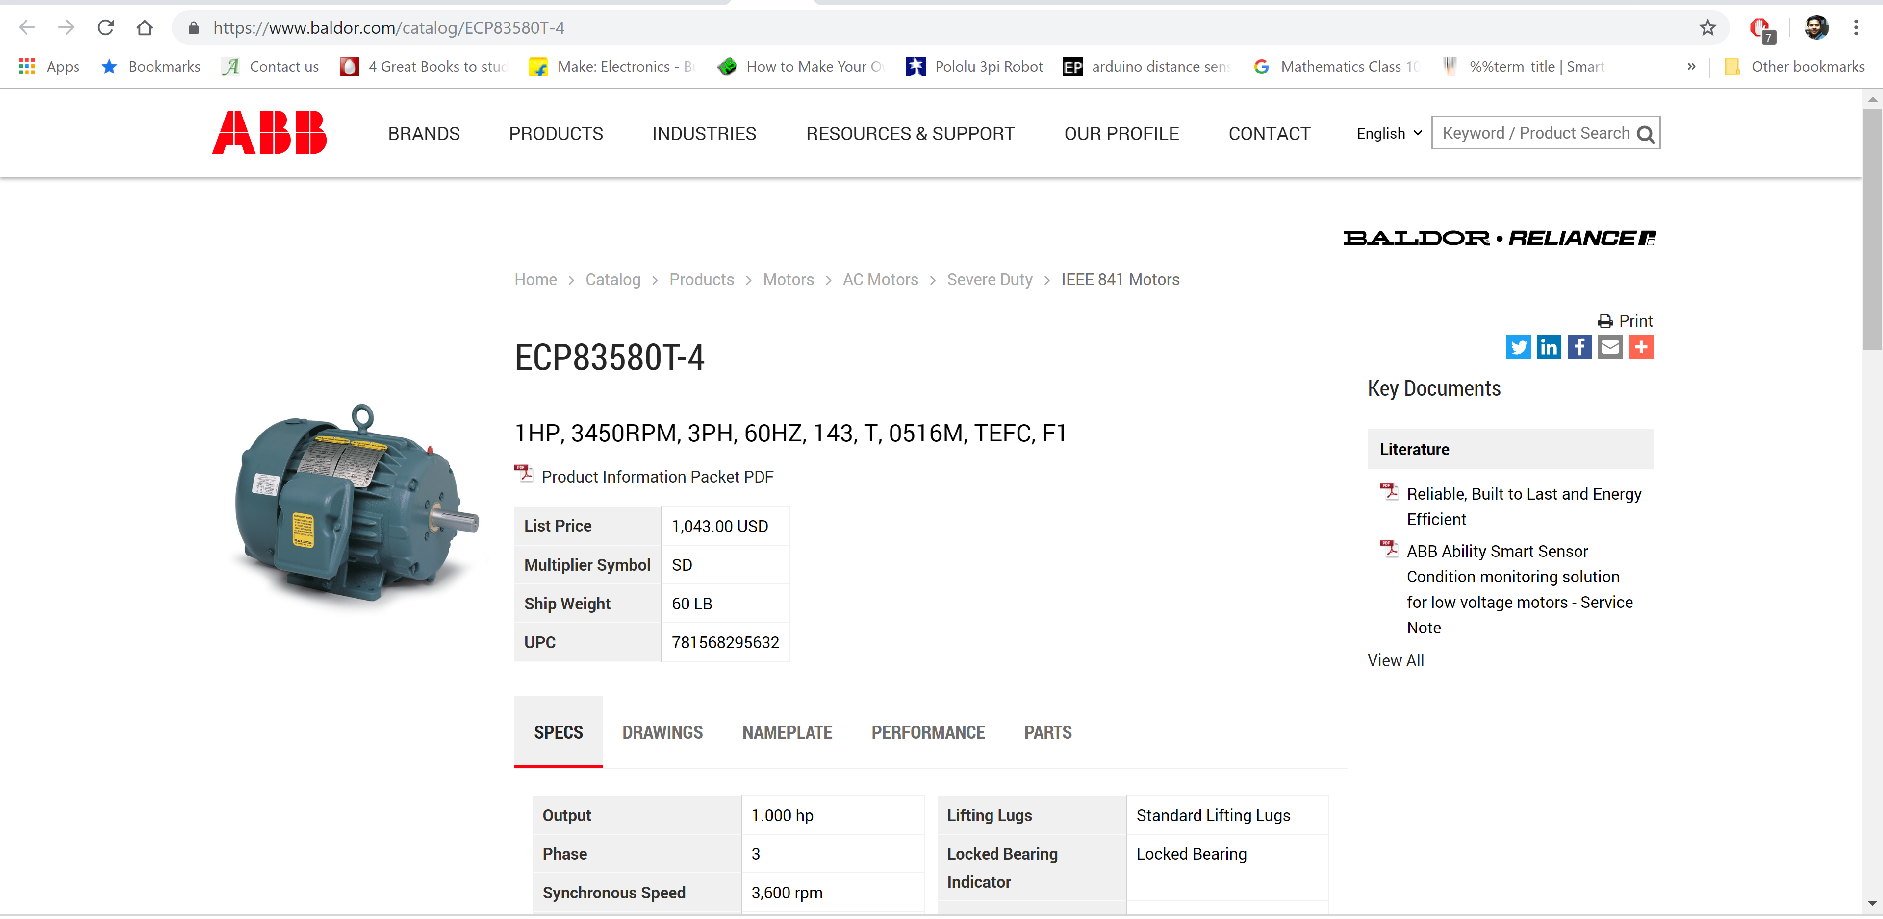

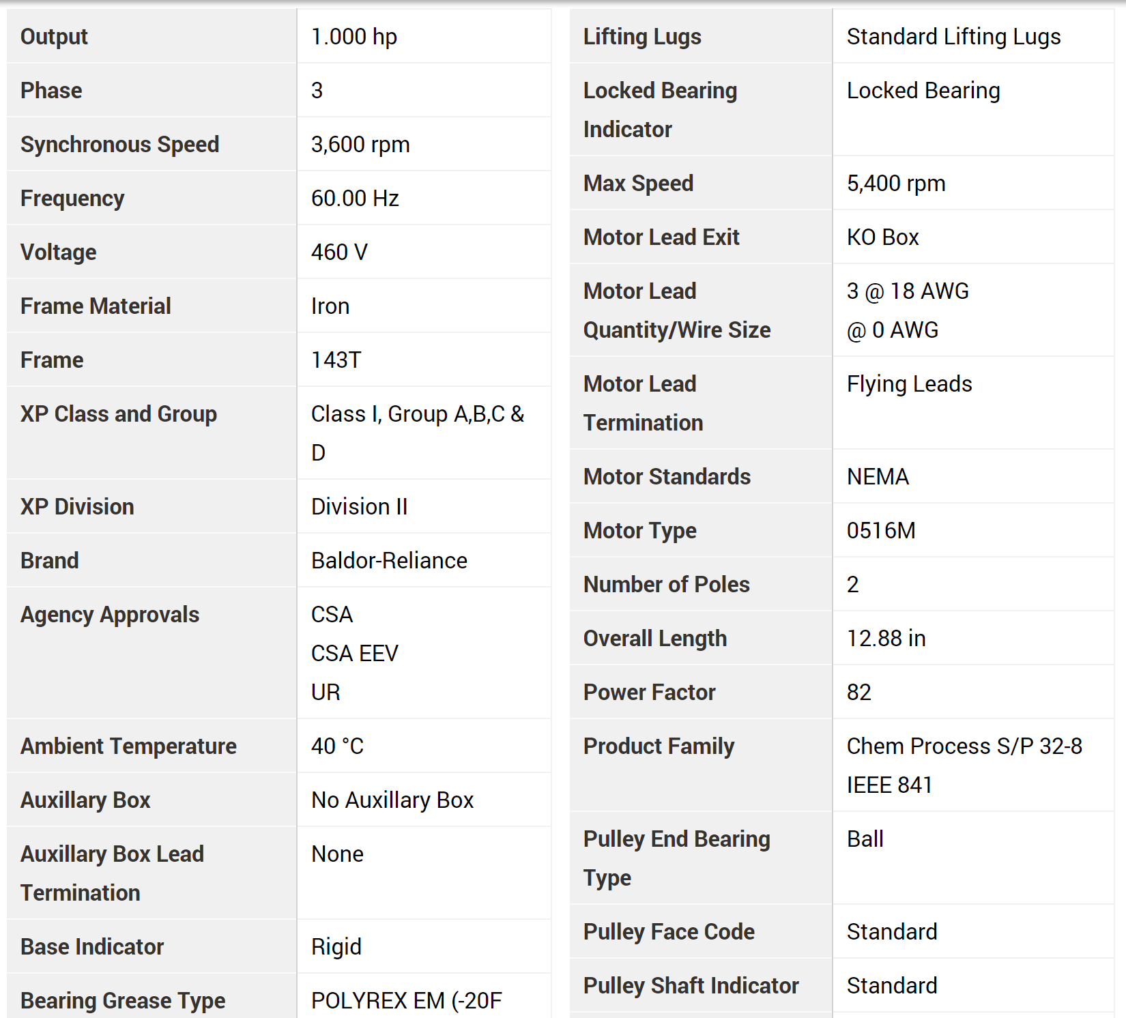

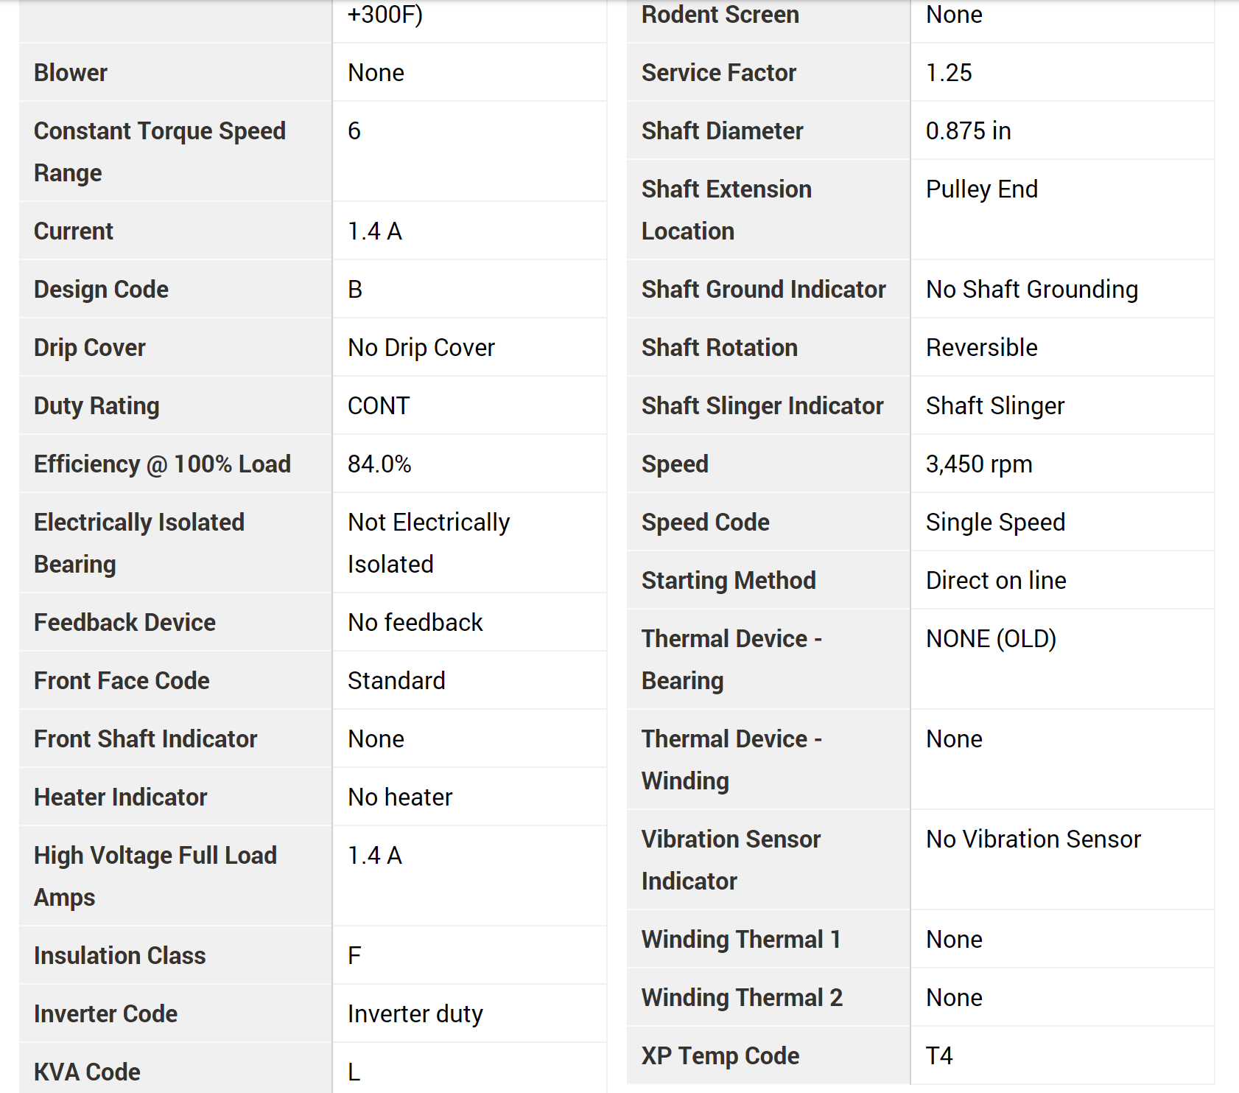

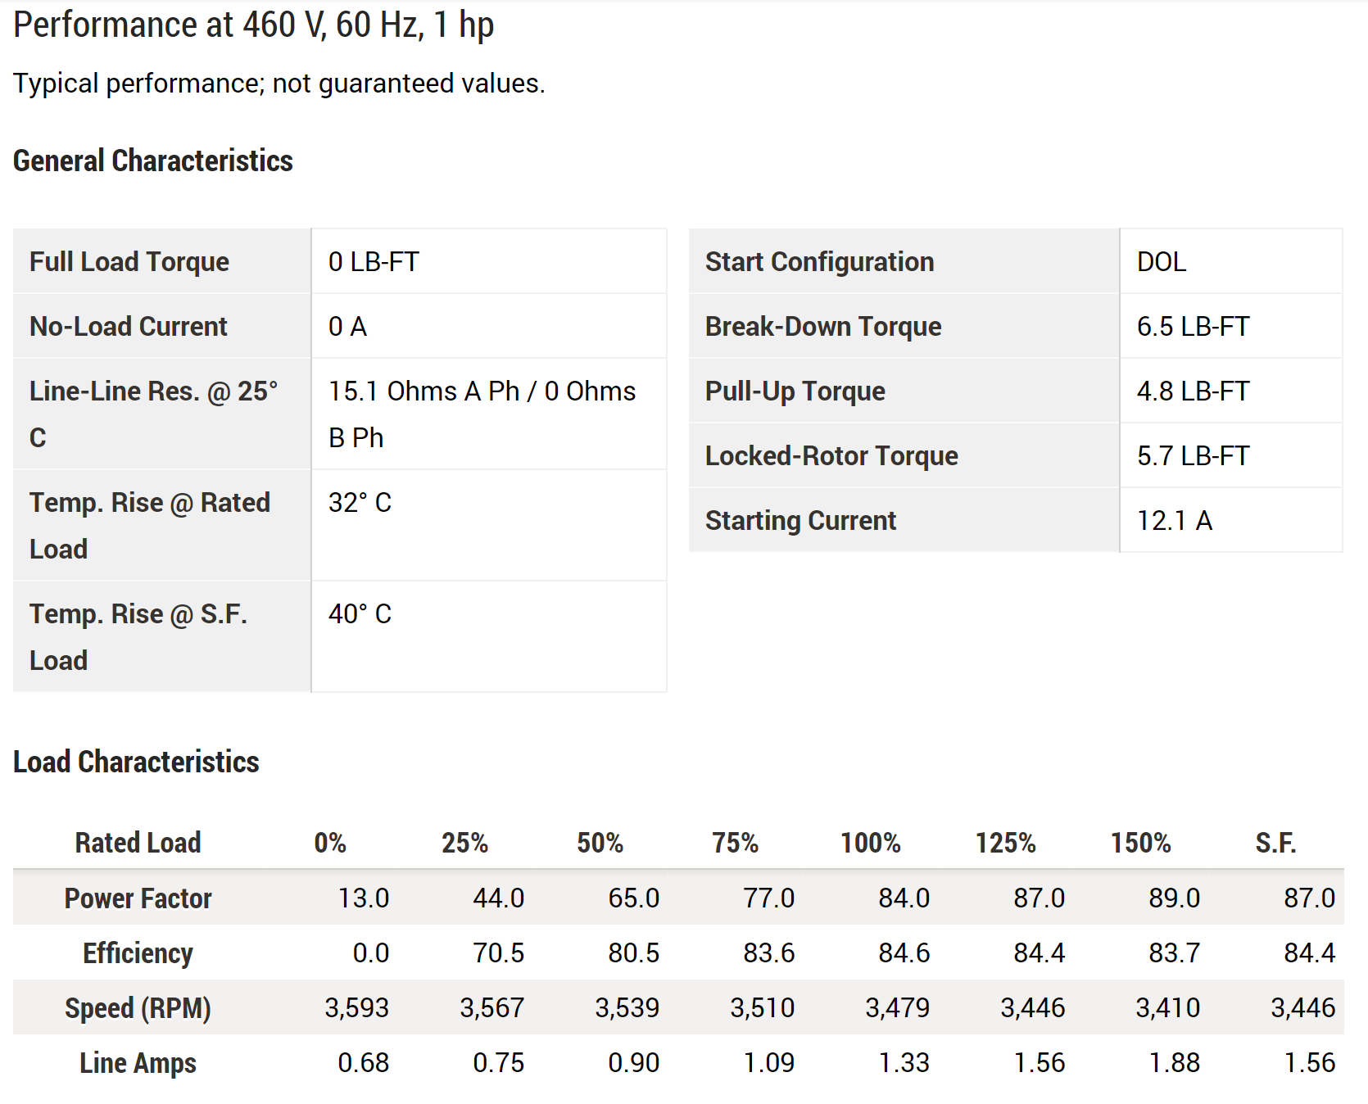

**Starting current** is rated at 12.1A, therefore maximum would be [**[22 – page 34]**](https://new.abb.com/docs/librariesprovider53/about-downloads/low-voltage-motor-guide.pdf)therefore **14.52A**

P.2. Select a suitable Square D brand motor starter from the web site [www.schneider-electric.us](http://www.schneider-electric.us) Show the part number and screen shots of the various motor specs that will allow you to select the other components needed.

Answer: Since the **starting current is less than 15A**, I would select this Square D motor starter: **LUB320** [**[23]**](https://www.schneider-electric.us/en/product/LUB320/power-base---tesys-u---32-a---no-connections-control/?range=682-tesys-u-combination-motor-starter&node=166391479-power-base&filter=business-4-low-voltage-products-and-systems&parent-category-id=50400&parent-subcategory-id=50430)

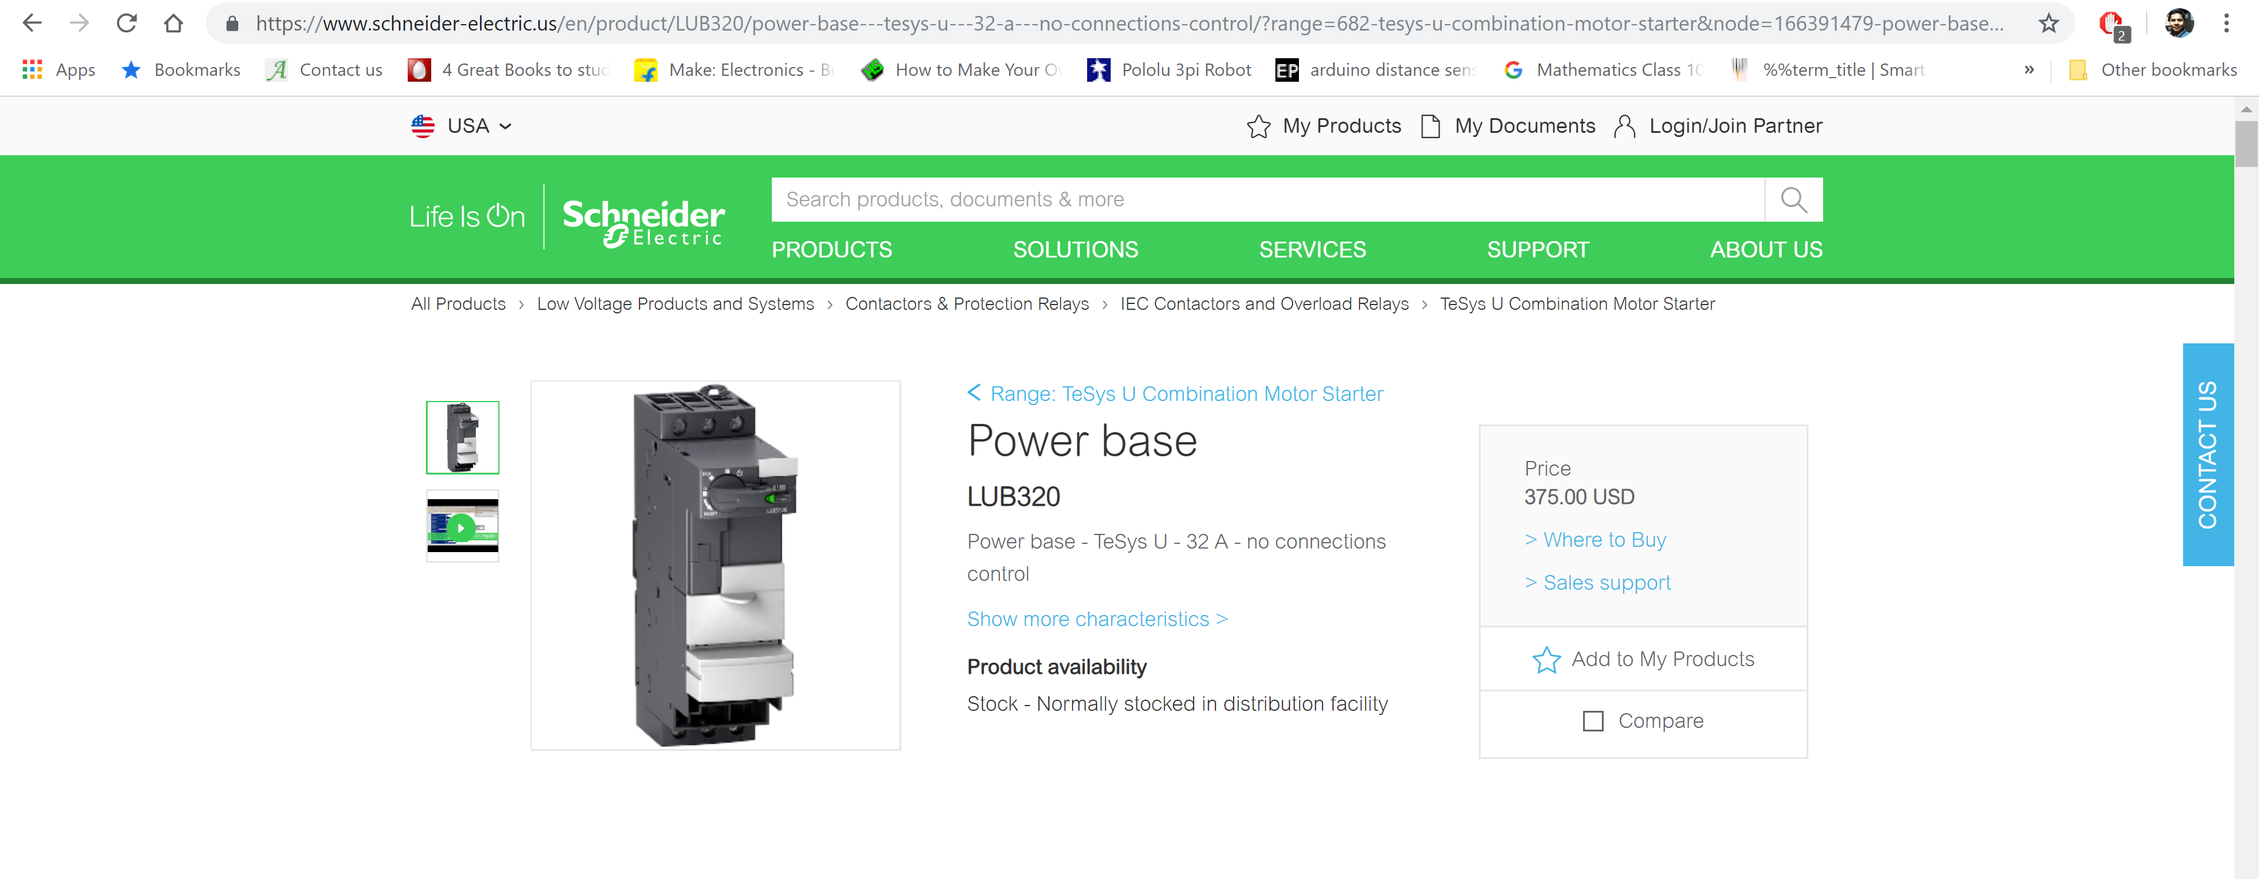

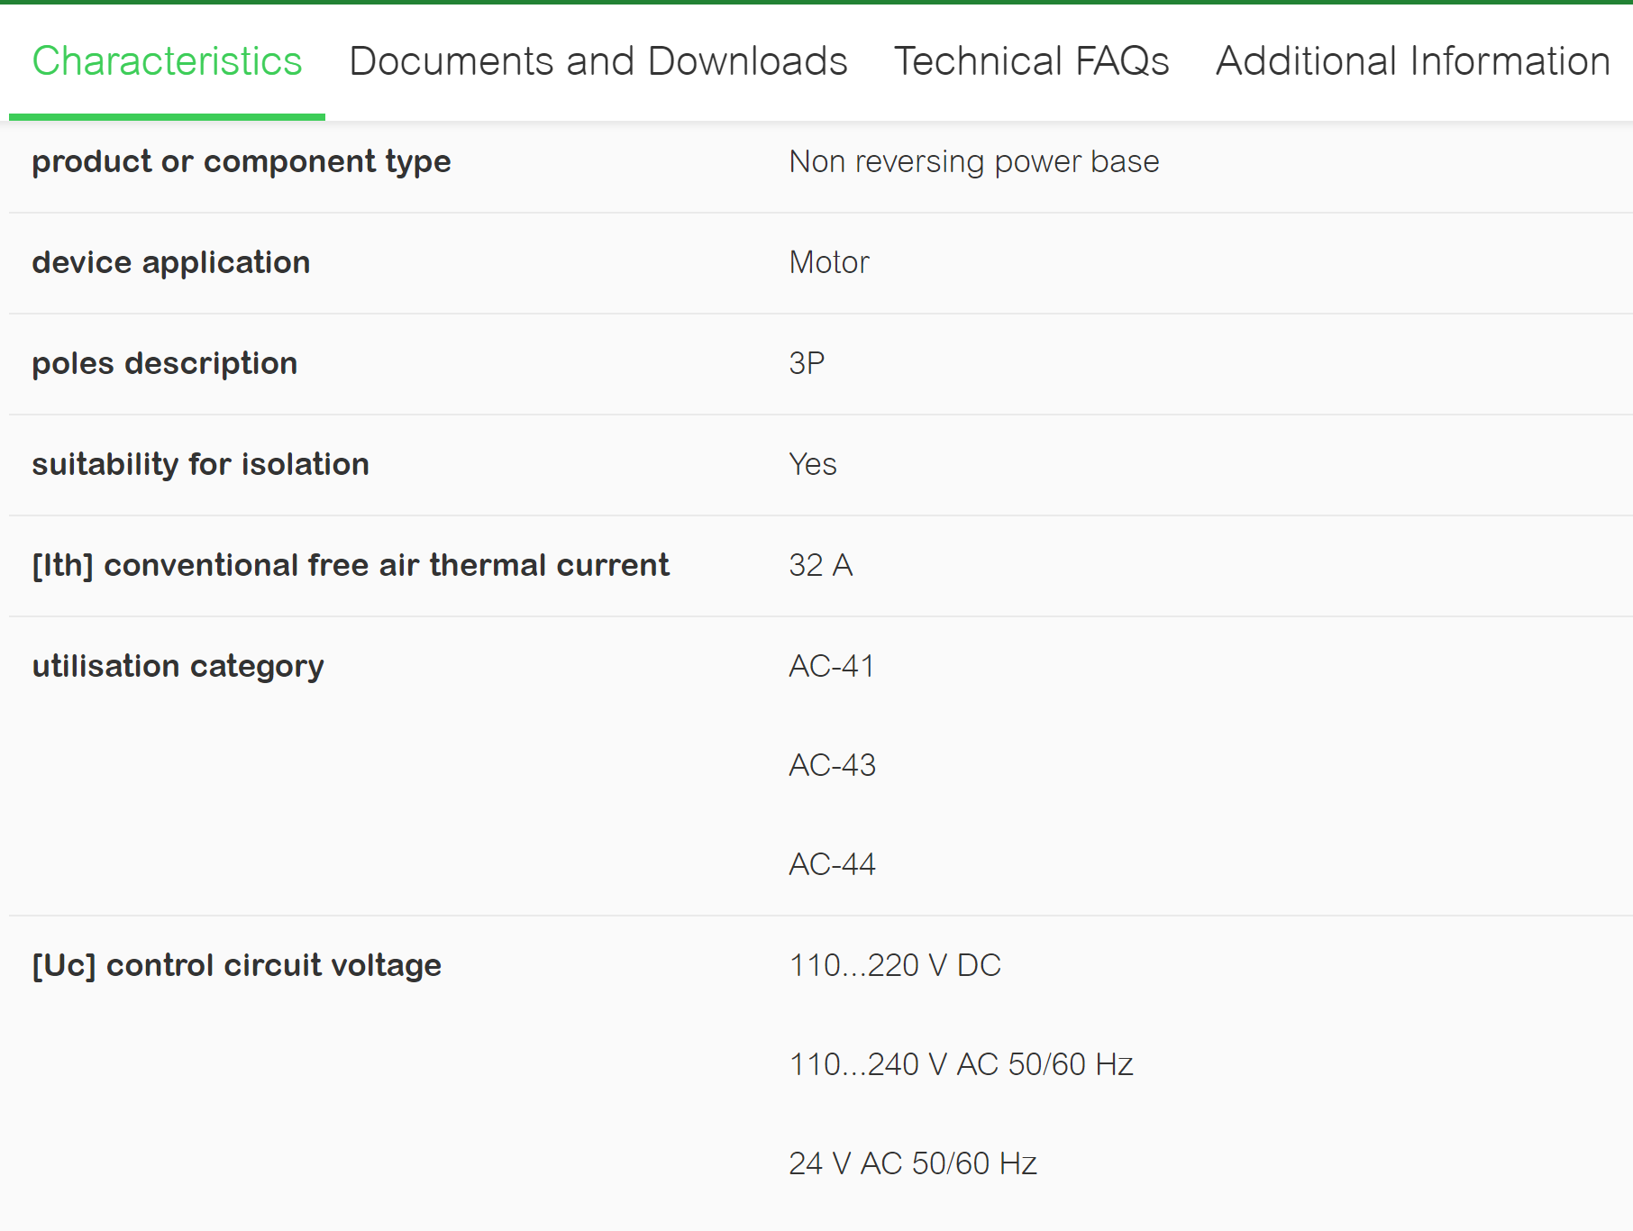

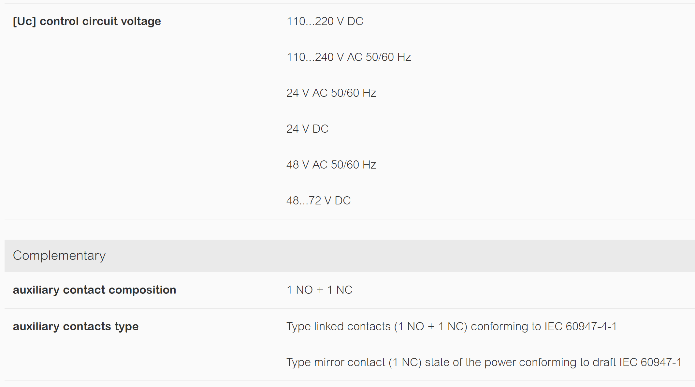

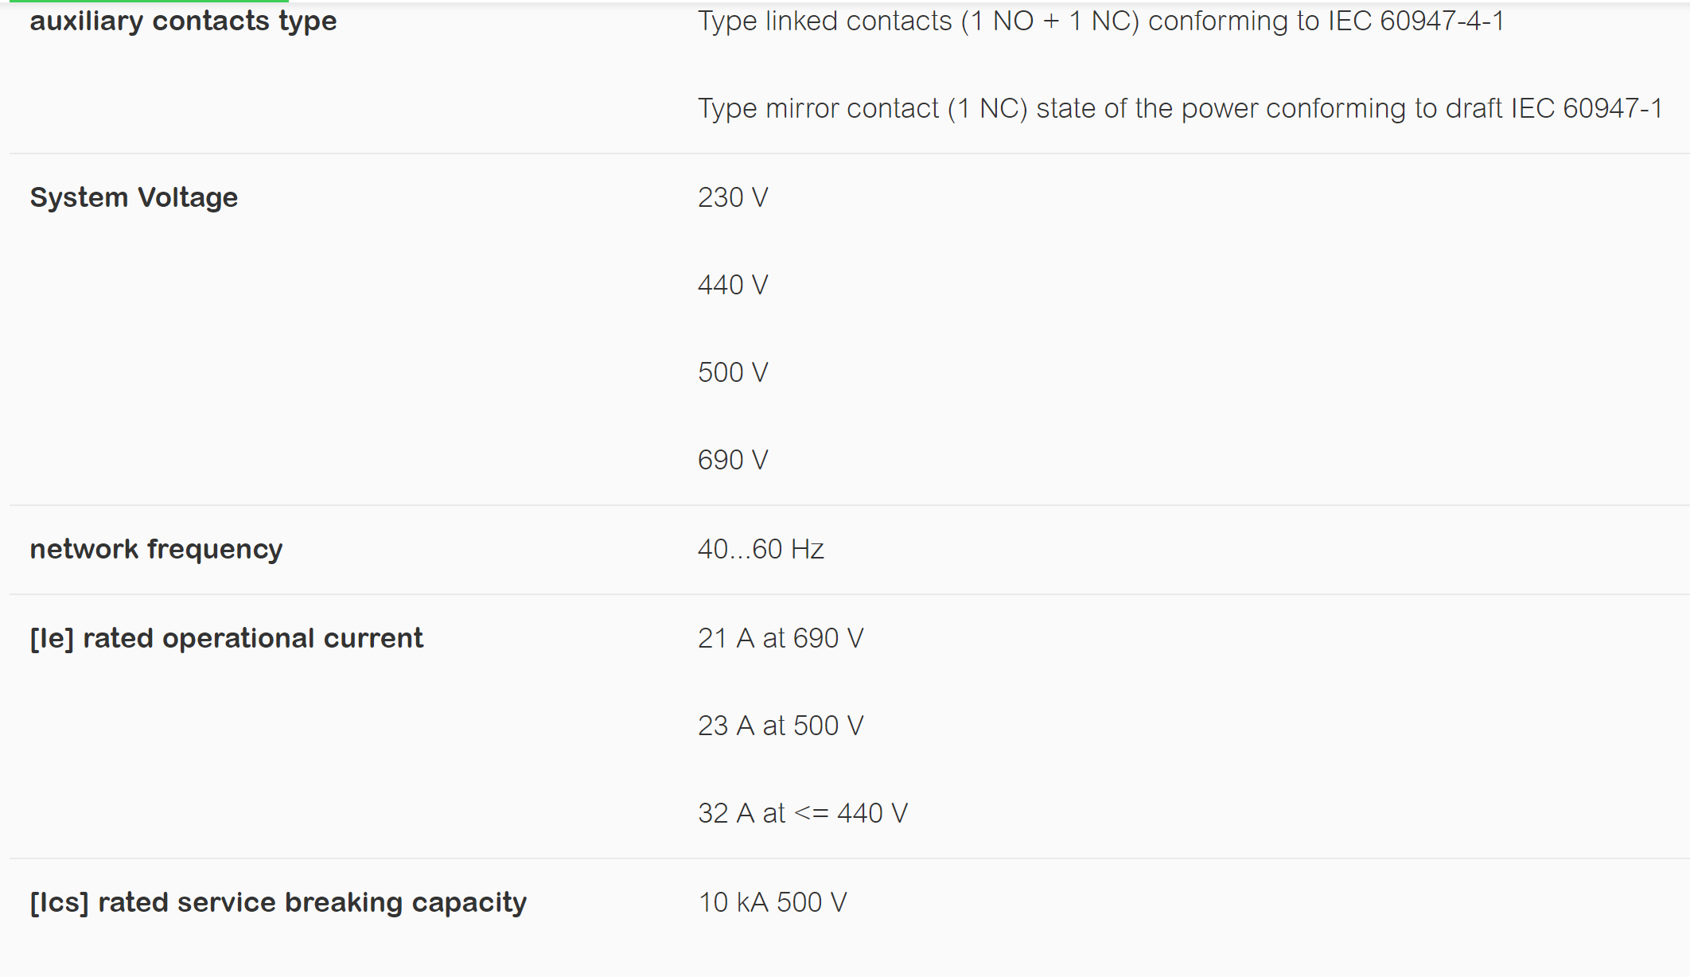

P.3. Select a suitable Square D brand thermal overload relay from the web site [www.schneider-electric.us](http://www.schneider-electric.us) Show the part number and screen shots of the various motor specs that will allow you to select the other components needed.

Answer: Since the selected motor **runs at 1.33A** at the torque and speed that the application requires, I have chosen the thermal overload relay which can be tuned in the **range of 1 to 1.6A**: **LR3D06** [**[24]**](https://www.schneider-electric.us/en/product/LR3D06/tesys-lrd-thermal-overload-relays---1...1.6-a---class-10a/?range=1885-tesys-lrd-overload-relays&node=166389602-thermal-overload-relays&filter=business-4-low-voltage-products-and-systems&parent-category-id=50400&parent-subcategory-id=50430)

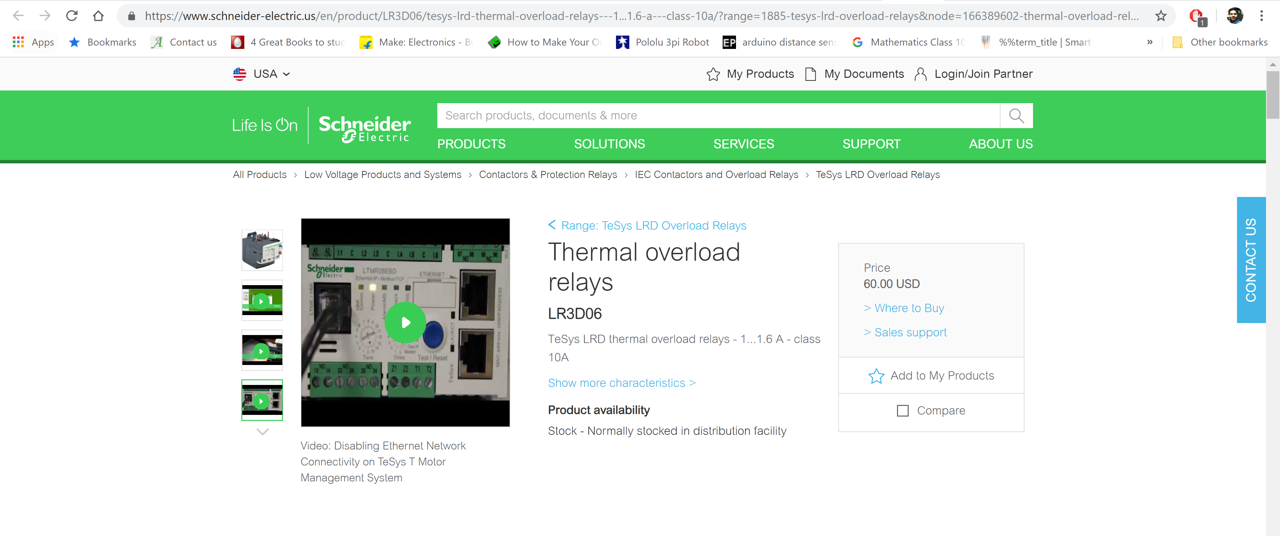

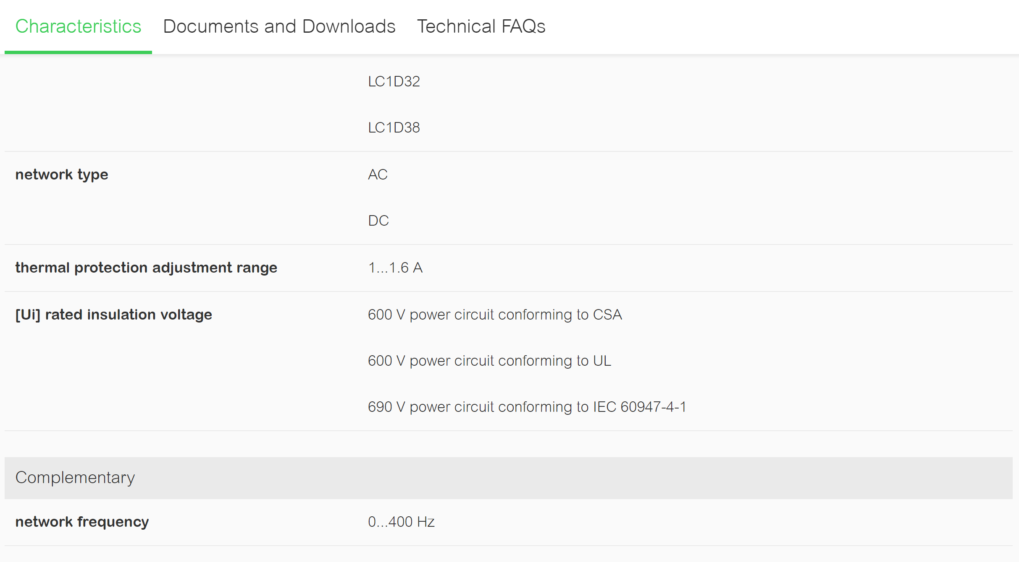

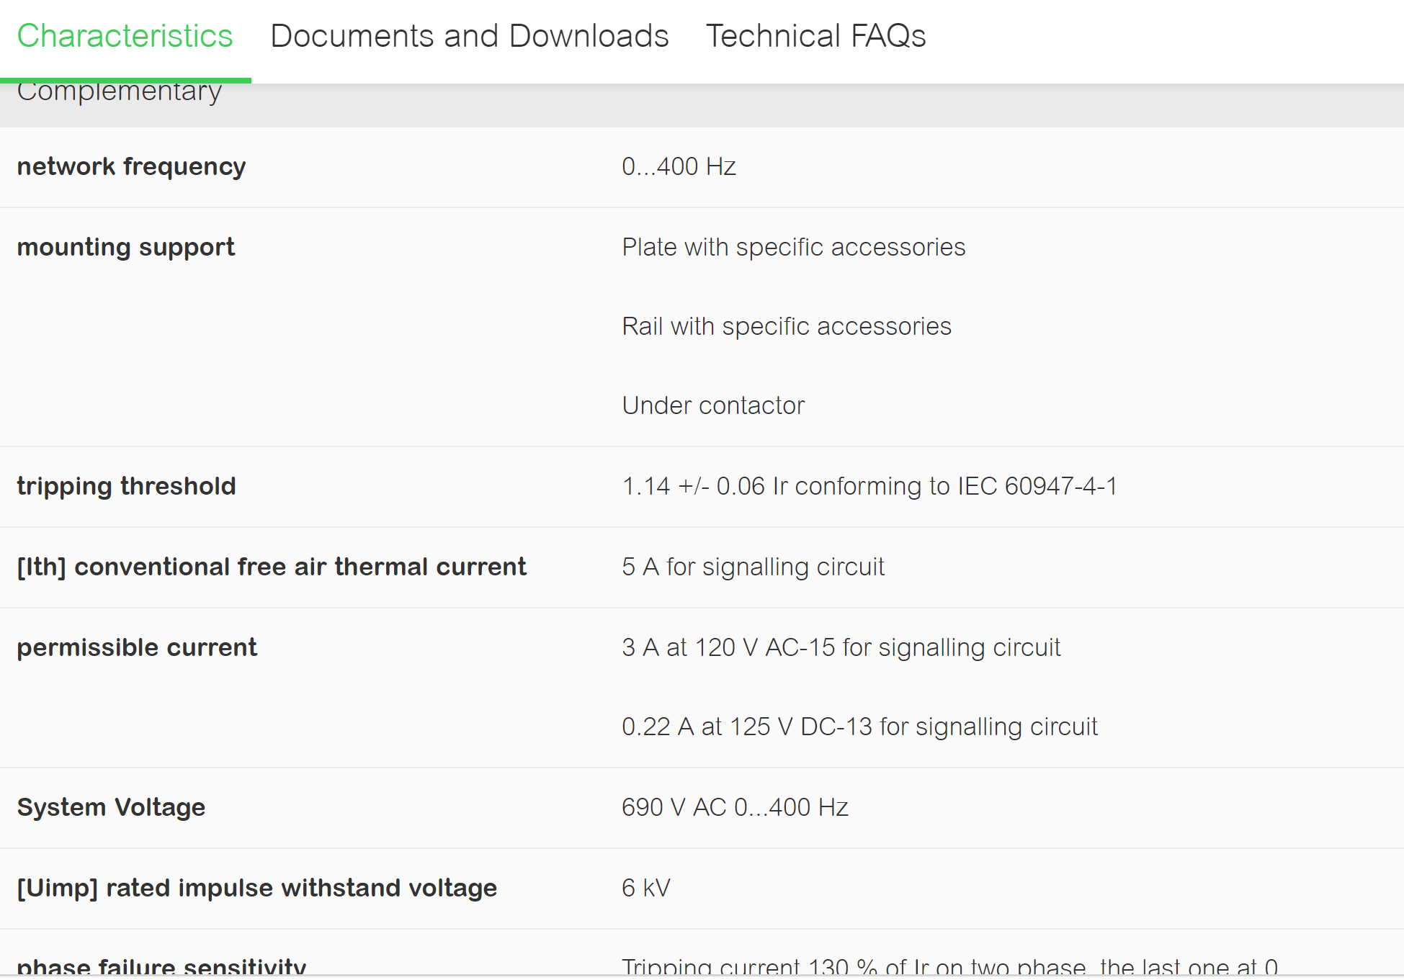

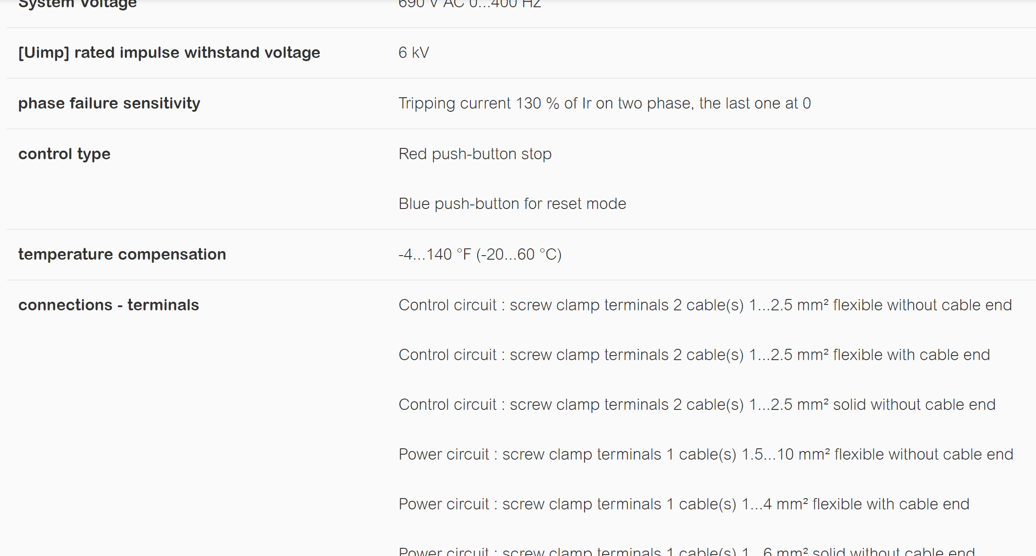

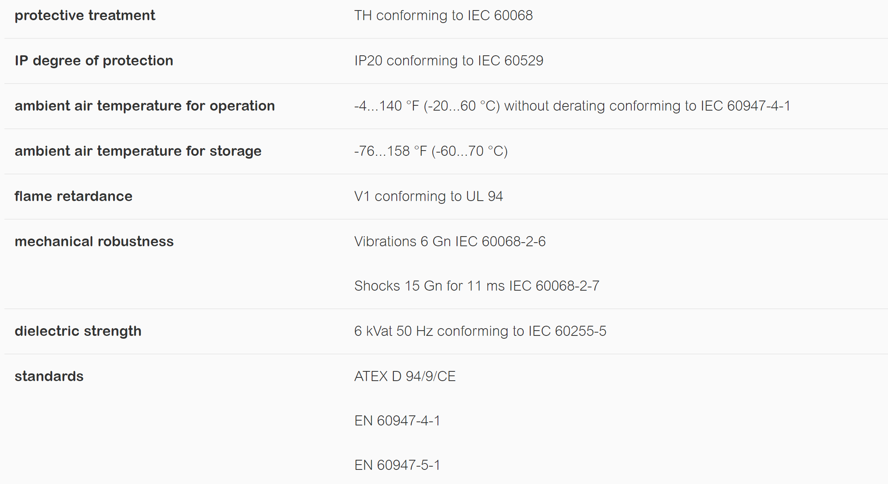

P.4. Select a suitable Siemens brand AC motor contactor from the web site [www.grainger.com](http://www.grainger.com). Show the part number and screen shots of the various motor specs that will allow you to select the other components needed.

Answer: The contactor has **9A rated current** which is more than enough since the selected motor only runs at 1.33A. Also, this contactor is by **Siemens**, with **3 poles**: **44F316** [**[25]**](https://www.grainger.com/product/SIEMENS-480VAC-NEMA-Magnetic-Contactor-44F316)

